

FOR IMMEDIATE RELEASE Media Contact: Ellen McGovern
Clinton Savings Bank
Main: 888-744-4272
Cell: 508-523-3536
marketing@clintonsavings.com

Clinton Savings Bank President & CEO Robert J. Paulhus, Jr., to Retire March 31, 2025

(CLINTON, Mass., August 28, 2024) – President & CEO of Clinton Savings Bank, Robert J. “Bob” Paulhus, Jr., has announced his planned retirement date of March 31, 2025. As part of the Company’s succession plan, the Board recently elected Mary T. Dean, Executive Vice President/Chief Information Officer, to become the Bank’s next President & CEO upon Bob’s retirement.

Bob has been a driving force behind the Bank’s success as a financial and community partner throughout the region for the past 25 years. Having been in banking in his entire 42-year career Bob successfully lead the commercial team at the Bank for nine years, rising to the rank of Executive Vice president in 2008 and ultimately attaining the position of President & CEO later that year. While Bob has enjoyed tremendous success as an executive, his greatest gift has been the opportunity to work with a talented and committed team of bankers at CSB, and to work closely with so many of the Bank’s customers throughout the region.

“We are extremely grateful for Bob’s longtime commitment to the Bank and our communities. While we’ll miss him being in an active role with the Bank, his mentorship will help the next generation of bankers build on his exceptional legacy of leadership and service. I will also personally miss Bob’s constant guidance and undisputable wisdom. We wish for Bob and his wife a healthy and happy new chapter in life,” said William E. O’Neil, Jr., Chairman of the Board.

About Clinton Savings Bank
Established in 1851, Clinton Savings Bank is among the oldest mutual community banks in Massachusetts with more than $735 million in assets. Clinton Savings Bank (CSB) offers business and consumer banking, through seven full-service branches in Berlin, Bolton, Boylston, Clinton, Shrewsbury, Sterling, West Boylston and as a member of the Allpoint network access to over 55,000 ATMs. CSB also provides mobile and online banking. For more information, please visit clintonsavings.com.

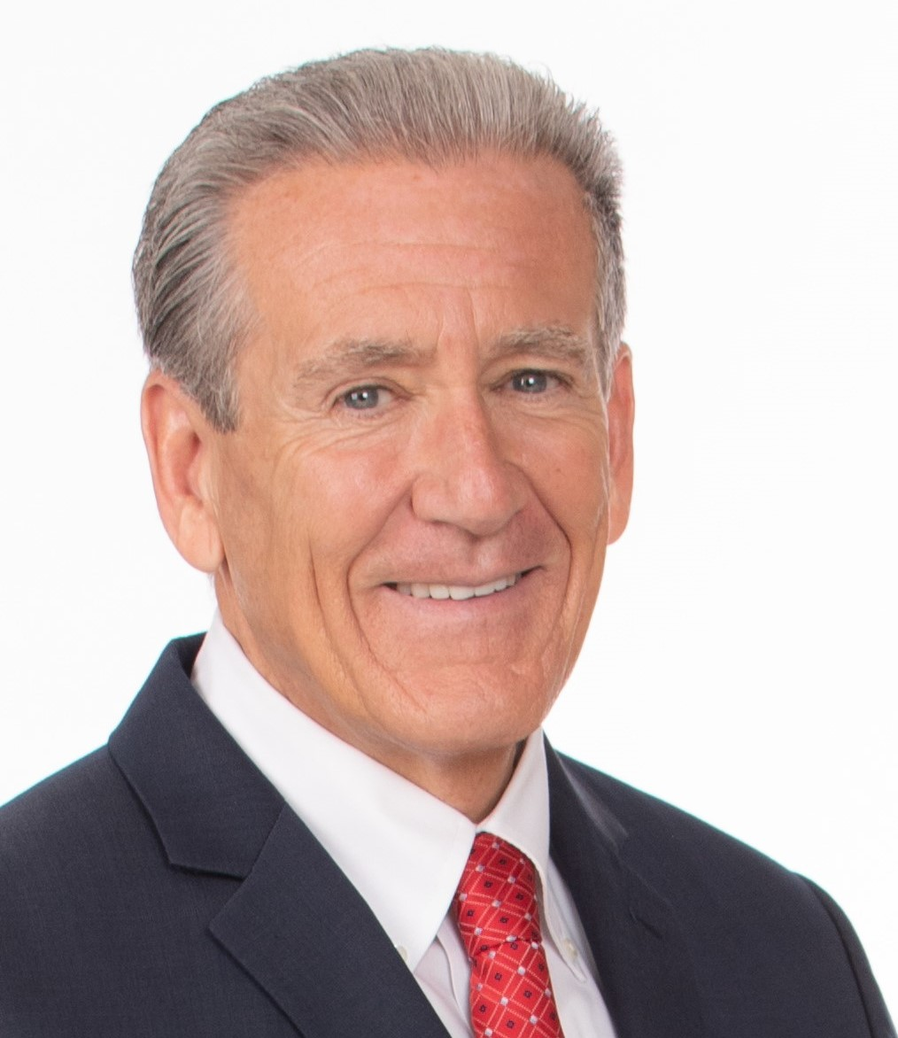
Robert J. Paulhus, Jr., President & CEO, Clinton Savings Bank

